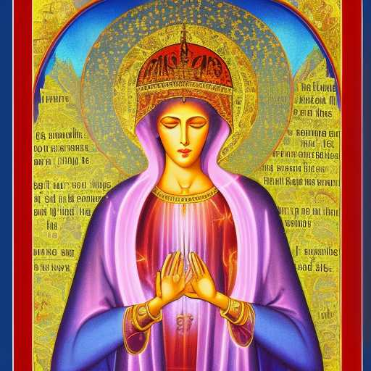
HER EVER-BLOSSOMING BEAUTY

The Divine Feminine is the Super Doctrine
God made a form of Herself for man to love
The Most Perfect Form is the Immaculate Conception
...or…
the Ever-Blossoming Beauty that expandeth the
Soul of the Lord

My complement seems beyond space-time
Eternally unrequited in some sense, because requited means tasted,
yet She tastes ever sweeter

The Eternal Longing of man to return to Her, mirrored by and married to an Unveiled Divine Benevolence,
beyond all forms

